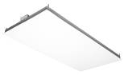
Watts | Volts | Width  In. (mm) | Height  In. (mm) | Amps | Weight  lb (kg) | Catalog  Number
24 x 24
250 | 120 | 24 (610) | 24 (610) | 2.1 | 15 (6.8) | AS2424-250-120¶
250 | 240 | 24 (610) | 24 (610) | 1.0 | 15 (6.8) | AS2424-250-240¶
250 | 277 | 24 (610) | 24 (610) | 0.9 | 15 (6.8) | AS2424-250-277¶
310 | 120 | 24 (610) | 24 (610) | 2.6 | 15 (6.8) | AS2424-310-120¶
310 | 208 | 24 (610) | 24 (610) | 1.5 | 15 (6.8) | AS2424-310-208¶
310 | 240 | 24 (610) | 24 (610) | 1.3 | 15 (6.8) | AS2424-310-240¶
310 | 277 | 24 (610) | 24 (610) | 1.1 | 15 (6.8) | AS2424-310-277¶
325 | 240 | 24 (610) | 24 (610) | 1.4 | 15 (6.8) | AS2424-325-240¶
335 | 120 | 24 (610) | 24 (610) | 2.8 | 15 (6.8) | AS2424-335-120¶
335 | 277 | 24 (610) | 24 (610) | 1.2 | 15 (6.8) | AS2424-335-277¶
355 | 208 | 24 (610) | 24 (610) | 1.7 | 15 (6.8) | AS2424-355-208¶
375 | 120 | 24 (610) | 24 (610) | 3.1 | 15 (6.8) | AS2424-375-120¶
375 | 208 | 24 (610) | 24 (610) | 1.8 | 15 (6.8) | AS2424-375-208¶
375 | 277 | 24 (610) | 24 (610) | 1.4 | 15 (6.8) | AS2424-375-277¶
24 x 48
500 | 120 | 24 (610) | 48 (1219) | 4.2 | 30 (13.6) | AS2448-500-120¶
500 | 240 | 24 (610) | 48 (1219) | 2.1 | 30 (13.6) | AS2448-500-240¶
500 | 277 | 24 (610) | 48 (1219) | 1.8 | 30 (13.6) | AS2448-500-277¶
535 | 208 | 24 (610) | 48 (1219) | 2.6 | 30 (13.6) | AS2448-535-208¶
625 | 120 | 24 (610) | 48 (1219) | 5.2 | 30 (13.6) | AS2448-625-120¶
625 | 208 | 24 (610) | 48 (1219) | 3.0 | 30 (13.6) | AS2448-625-208¶
625 | 240 | 24 (610) | 48 (1219) | 2.6 | 30 (13.6) | AS2448-625-240¶
660 | 277 | 24 (610) | 48 (1219) | 2.4 | 30 (13.6) | AS2448-660-277¶
725 | 240 | 24 (610) | 48 (1219) | 3.0 | 30 (13.6) | AS2448-725-240¶
750 | 120 | 24 (610) | 48 (1219) | 6.3 | 30 (13.6) | AS2448-750-120¶
750 | 208 | 24 (610) | 48 (1219) | 3.6 | 30 (13.6) | AS2448-750-208¶
750 | 277 | 24 (610) | 48 (1219) | 6.3 | 30 (13.6) | AS2448-750-277¶
14 x 48
300 | 240 | 14 (356) | 48 (1219) | 1.3 | 18 (8.2) | AS1448-300-240¶
350 | 120 | 14 (356) | 48 (1219) | 2.9 | 18 (8.2) | AS1448-350-120¶
350 | 277 | 14 (356) | 48 (1219) | 1.3 | 18 (8.2) | AS1448-350-277¶
400 | 208 | 14 (356) | 48 (1219) | 1.9 | 18 (8.2) | AS1448-400-208¶
435 | 208 | 14 (356) | 48 (1219) | 2.1 | 18 (8.2) | AS1448-435-208¶
435 | 240 | 14 (356) | 48 (1219) | 1.8 | 18 (8.2) | AS1448-435-240¶
435 | 277 | 14 (356) | 48 (1219) | 1.6 | 18 (8.2) | AS1448-435-277¶
14 x 60
350 | 120 | 14 (356) | 60 (1524) | 2.9 | 22 (10.0) | AS1460-350-120¶
375 | 240 | 14 (356) | 60 (1524) | 1.6 | 22 (10.0) | AS1460-375-240¶
375 | 277 | 14 (356) | 60 (1524) | 1.4 | 22 (10.0) | AS1460-375-277¶
450 | 208 | 14 (356) | 60 (1524) | 2.2 | 22 (10.0) | AS1460-450-208¶
535 | 277 | 14 (356) | 60 (1524) | 1.9 | 22 (10.0) | AS1460-535-277¶
550 | 240 | 14 (356) | 60 (1524) | 2.3 | 22 (10.0) | AS1460-550-240¶
¶Add finish code.

Factory Built-in Options
Code | Description
FC | 48” Flexible conduit.
S | Silicone seams, provides protection in high moisture areas. Includes 36” of sealtite conduit.
TEGF | Fineline Tegular reveal edge for 9/16” grid.

Field-Installed Options
(shipped loose for field installation into heaters)
Catalog  Number | Width  In. (mm) | Length  In. (mm) | Weight  lb (kg)
Surface Mounting Frames

SF-22¶ | 24 (610) | 24 (610) | 4 (1.8)
SF-24¶ | 24 (610) | 48 (1219) | 9 (4.1)
SF-1448¶ | 14 (356) | 48 (1219) | 8 (3.6)
SF-1460¶ | 14 (356) | 60 (1524) | 10 (4.5)
Plaster Mounting Frames
PF-22¶ | 24 (610) | 24 (610) | 2 (1.0)
PF-24¶ | 24 (610) | 48 (1219) | 4 (1.8)
SPF-24(1) | 24 (610) | 48 (1219) | 4 (1.8)
PF-1448¶ | 14 (356) | 48 (1219) | 5 (2.3)
PF-1460¶ | 14 (356) | 60 (1524) | 6 (2.7)
Filler Panel
FP | Sized and finished to match standard, custom color.
¶ Add finish code.
(1) 304 Stainless steel frame
Finishes¶
Code | Description
O | Specify custom color finish.
PT | Standard finish; textured white baked-on powder coating on front panel.
S304 | 304 Stainless steel construction, includes 36” of sealtite conduit and silicone seal.

Control Options
Catalog Number | Description
SR-LV | SmartRooms low voltage controller. Sensor(s) must be ordered at the same time.  Requires connection to SmartRooms Communication Panel.
PL-1 | Plaster ring for SR-LV Controller
Sensors | Used with SR-240/120, 15’ long
 | Longer length add per foot
SRDP-10/10 | SmartRooms Panel w/10comm. Ports and 10 ea. 20 amp relays
SRDP-10/20 | SmartRooms Panel w/10comm. Ports and 20 ea. 20 amp relays
SRDP-20/20 | SmartRooms Panel w/20comm. Ports and 20 ea. 20 amp relays

Thermostats for AS Series Radiant Ceiling Panels
Catalog Number | Switch  Type | Color | Type | Tamper-  proof | Thermometer | Amps @  120-240V | Amps @ 277V | Pilot  Duty | Positive  Off | Temperature  Range ºF
R-101 | Bimetal | Beige | SPST | No | No | 22 | 18 | -- | No | 40-85
R-102 |  |  | DPST | No | No |  |  | -- | Yes | 40-85
(4) A 3 inch deep double electrical box will be supplied for wall installation. Remote window sensor option is available, contact factory for pricing.

Notes:
(1) All panels are single-phase.
(2) Standard finish is a textured white baked on powder coat.
(3) Standard panels are furnished with a 4” x 4” x 1-½ junction box with cover for field electrical connection.
(4) Corner support clips are furnished on each panel. Clips have holes for support wires/chains for mounting and earthquake requirements.

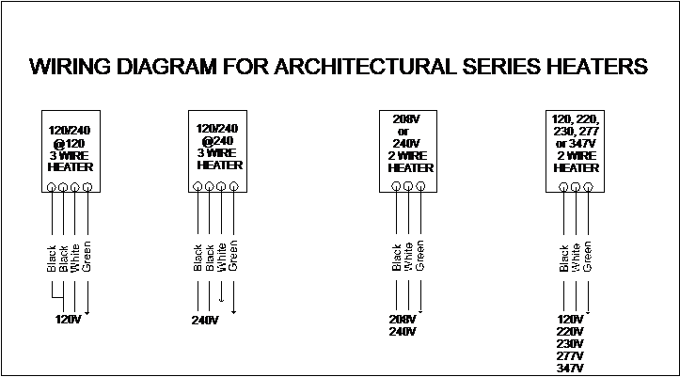
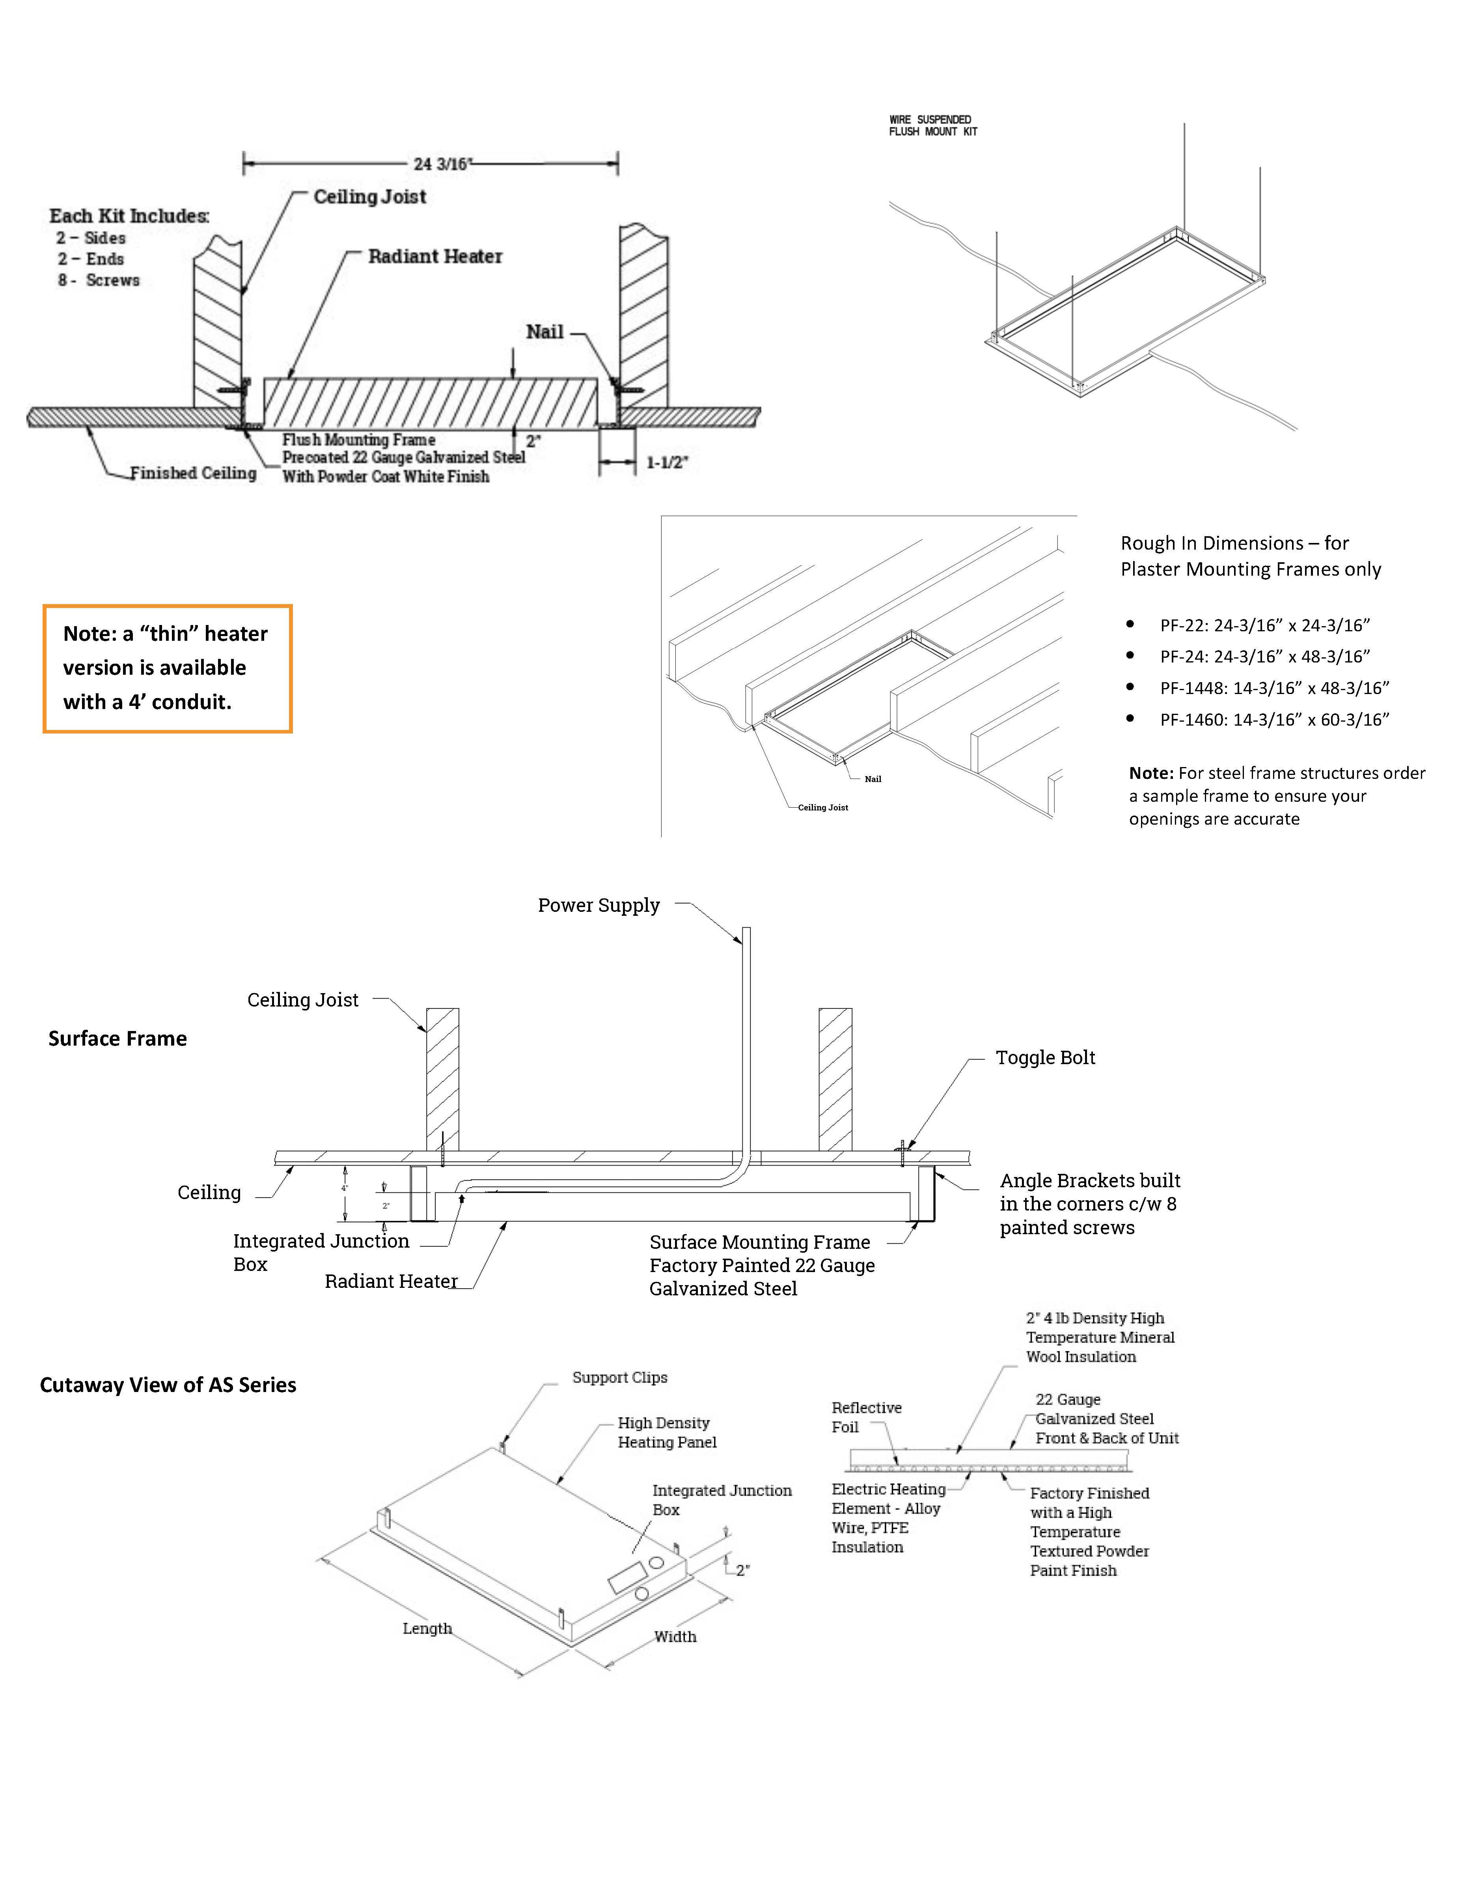
Architect’s and Engineer’s Specifications

- Electric radiant ceiling panels shall be by INDEECO, construction and options as shown below. Panels shall be _{c}ETL_{us} Listed, for the wattage, voltage and size as specified in the schedule.
- Panels shall use a high-quality alloy resistance wire element electrically insulated with an approved TEFZEL® compound rated at 200°C. The heating element is uniformly arranged over the entire face of the panel to provide evenly distributed radiant heat. High-efficient reflective foils are used to adhere the heating element to the radiant panel.
- Panels are to be designed with a watt density range of 65-95 watts/ft² at rated voltage.
- The panel shall contain two-inch thick, four-pound density high temperature mineral wool insulation. Fiberglass insulation is not acceptable.
- Panel shall be constructed from heavy 22-gauge galvanized steel. Front panel shall be finished with a white textured high temperature baked on powder coat. Textured finish enhances the radiant effect by providing a wider scattering of the radiant energy, increasing the panels overall efficiency.
- Panels will be a two-piece construction crimped together for strength and rigidity. Pop rivet construction is not acceptable.
- Panel shall be provided with an electrical junction box attached to the back of the panel. Junction box shall be 4 x 4 x 1-1/2 inches and shall be provided with a cover. Internal pigtail wires shall be provided for field wiring connection.
- Hanging/support clips in each corner shall be provided for local code and earthquake installation requirements.
- Provide special finishes. [Check off one of the following options]:
Radiant panels to be silk-screened to match sample provided of architectural ceiling title.
Custom color panels to match color sample provided. Finish to be baked on high temperature powder coat.
304 Grade Stainless steel panel with 36-inch long sealtite conduit and silicone seal seam.
- Provide panel with the following optional mounting system. [Check off one of the following options]:
Surface mounting frame kits sized to radiant panel heater.
Plaster mounting frame kits sized to radiant panel heater.
Radiant panel with Fineline Tegular reveal edge for 9/16-inch grid.
- Additional special features. [Check off options to be included]:
48” Sealtite flexible conduit and connectors for use in high moisture areas.
Silicone sealed seams for moisture protection in high moisture areas.
- The following accessories shall be factory furnished for field installation. [Check off options to be included]:
Filler panels to match panel style and finish. Provides a continuous appearance along ceiling line.
Wall mounted thermostat.

