
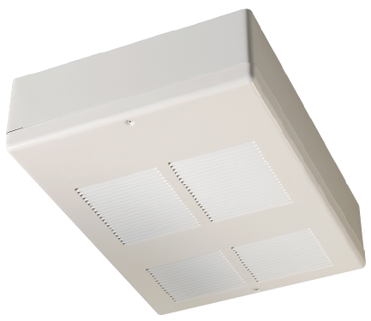
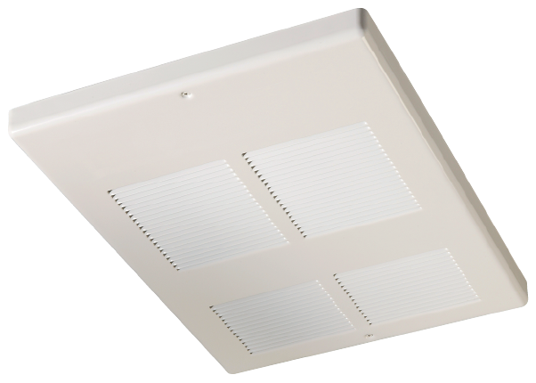

Watts | Volts | Total  Amps (1) | CFM | Approximate Air Temperature Rise ºF (ºC) | Weight  lb (kg) | Catalog  Number
1500/1125 | 240/208 | 6.6/5.8 | 160 | 30/27 (17/12) | 20 (9) | 931U01500V¶
1500 | 120 | 12.9 | 160 | 30 (17) | 24 (11) | 931U01500B¶
1500 | 277 | 5.8 | 160 | 30 (17) | 26 (12) | 931U01500N¶
1500 | 480 | 3.5 | 160 | 30 (17) | 26 (12) | 931U01500T¶
2000/1500 | 240/208 | 8.7/7.6 | 160 | 40/30 (22/17) | 20 (9) | 931U02000V¶
2000 | 277 | 7.6 | 160 | 40 (22) | 26 (12) | 931U02000N¶
2000 | 480 | 4.5 | 160 | 40 (22) | 26 (12) | 931U02000T¶
3000/2250 | 240/208 | 12.9/11.2 | 160 | 60/45 (33/25) | 20 (9) | 931U03000V¶
3000 | 277 | 11.2 | 160 | 60 (33) | 26 (12) | 931U03000N¶
3000 | 480 | 6.6 | 160 | 60 (33) | 26 (12) | 931U03000T¶
4000/3000 | 240/208 | 17.0/14.8 | 160 | 80/60 (44/33) | 20 (9) | 931U04000V¶
4000 | 208 | 19.6 | 160 | 80 (44) | 20 (9) | 931U04000C¶
4000 | 277 | 14.8 | 160 | 80 (44) | 26 (12) | 931U04000N¶
4000 | 480 | 8.7 | 160 | 80 (44) | 26 (12) | 931U04000T¶
4800/3600 | 240/208 | 20.5/208 | 160 | 95/83 (53/46) | 24 (11) | 931U04800V¶
4800 | 208 | 23.6 | 160 | 95 (53) | 24 (11) | 931U04800C¶
6000/4500 | 240/208 | 25.4/22.0 | 320 | 60/45 (33/25) | 40 (18) | 931U06000V¶
6000 | 277 | 22.1 | 320 | 60 (33) | 52 (24) | 931U06000N¶
6000 | 480 | 12.9 | 320 | 60 (33) | 52 (24) | 931U06000T¶
8000/6000 | 240/208 | 33.7/29.2 | 320 | 80/60 (44/33) | 40 (18) | 931U08000V¶
8000 | 208 | 38.9 | 320 | 80 (44) | 40 (18) | 931U08000C¶
8000 | 277 | 29.3 | 320 | 80 (44) | 52 (24) | 931U08000N¶
8000 | 480 | 17.1 | 320 | 80 (44) | 52 (24) | 931U08000T¶

(1) Total Amps includes motor amps.
Only single-phase available.
Other single-phase voltages are available. Consult factory.
¶ Standard colors - Add W for white finish or A for almond finish to the end of catalog number.
Special or custom colors available consult factory and add to end of catalog number.

Factory Built-in Options
Code | Description
D1 | Disconnect Switch 600V, Three-pole, 32 Amp
D2 | Disconnect Switch, 600V, Three-pole, 64 Amp
D3 | Disconnect Switch 277V, Double-pole, 16 Amp
R1 | 24V Relay
R2 | 24V Relay with Transformer (1)
T1 | Tamperproof Thermostat
T2 | Adjustable Thermostat
(1) Not Available for 120V heaters
Field-Installed Options
(shipped loose for field Installation into heater)
Catalog  Number | Description
931-124506¶ | Surface Mounting Box (1500-4800 W)
931-158213¶ | Surface Mounting Box (6000-8000 W)
931-124507¶ | Built-in Thermostat Kit (both knob & tamperproof plug provided)
931-124508 | 24V Control Relay Kit
931-124512¶ | T-Bar Adapter 23-¾” x 23-¾” (1500- 4800 W)
931-124513¶ | T-Bar Adapter 23-¾” x 47-11/16” (6000-8000 W)
931-218272¶ | Extruded Aluminum Front Grille (1500-4800W)
931-218273¶ | Extruded Aluminum Front Grille (6000-8000W)
931-218274¶ | Surface Mounting Box for Aluminum Front Grille (1500-4800W)
931-218275¶ | Surface Mounting Box for Aluminum Front Grille (6000-8000W)
¶ Standard colors - Add W for white finish or A for almond finish to the end of catalog number.
Special or custom colors available. Consult factory.

1500/1125-4800 6000/4500-8000
Watt Heater Watt Heater

Architect’s and Engineer’s Specifications
The specified heating equipment shall include an electric, fan-forced air ceiling heater suitable for space heating as manufactured by INDEECO. The ceiling heater shall be designed for wall recess or surface mounting. Heaters shall be third party approved to CSA standards. Reference: UL standard 2021.

Heater Housing shall be constructed from heavy 18-gauge steel.
Grille shall have a white or almond epoxy/powder paint finish. Grille openings shall be less than 0.25” to discourage tampering with the elements (pencil-proof). Contact factory for custom colors.
Heater Element shall be of finned tubular type.
Fan Motor shall be permanently lubricated, open and ventilated fan. The single unit has a 160 CFM fan (55.5 dBA) and the double unit has 2 x 160 CFM fans (58.5 dBA).
Fan Over-ride shall purge heater of residual heat to prevent an over heat condition.
Thermal Cutout shall be of the bi-metal type and built into the system.
Thermostat is optional and shall be built into the system as either tamperproof or adjustable.
Disconnect Switch is offered as an option and is built into the back of the system. The disconnect switch shall provide positive disconnect of the main power source.
Low Voltage Relays with or without transformers are available built-in or supplied separately as kits.
T-Bar Adapter is available as an option. T-Bar adaptor measures 23-3/4 x 23-3/4 inches.
Rough In Dimensions
- 1500/1125 – 4800 Watt heaters: 14-1/2” wide x 19-7/8” high x 4-1/2” deep.
- 6000/4500 – 8000 Watt heaters: 30-3/16” wide x 19-7/8” high x 4-1/2” deep.

