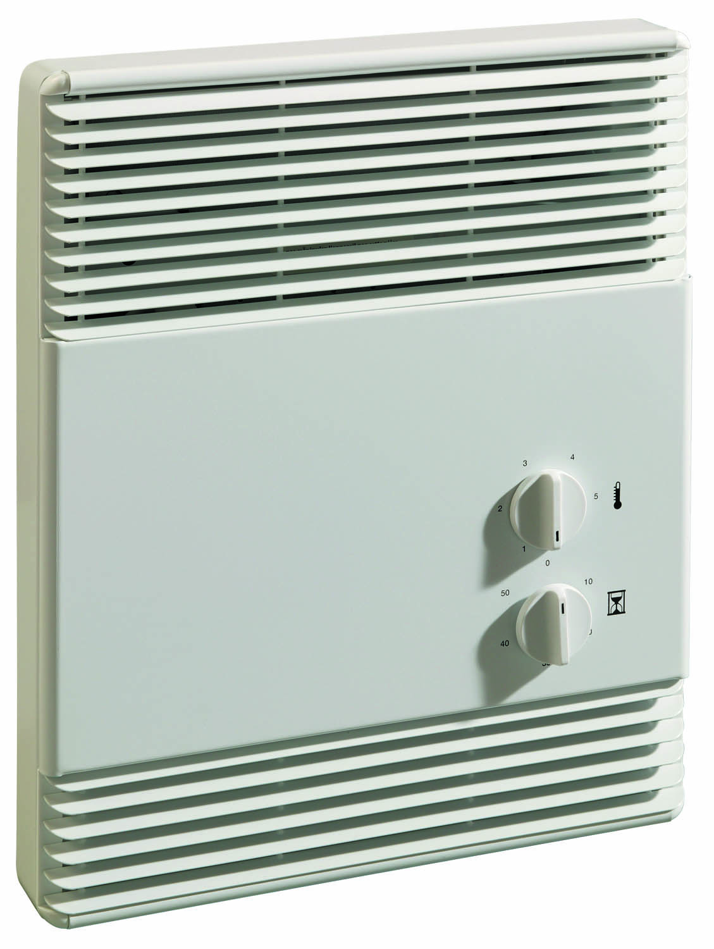


Watts |  | Volts | Total  Amps (1) | CFM |  | Maximum Air Temperature  Rise ºF (ºC) | Weight  lb (kg) | Catalog  Number (2)
Min. | Max. | Volts | Total  Amps (1) | Min. | Max.
- | 1500 | 120 | 13.0 | - | 70 | 68 (38) | 14 (6) | 935U01500B¶
750 | 1500 | 120 | 13.0 | 35 | 70 | 68 (38) | 14 (6) | 935U01500B¶-T
750 | 1500 | 120 | 13.0 | 35 | 70 | 68 (38) | 14 (6) | 935U01500B¶-TZ
- | 1500/1125 | 240/208 | 6.7/5.9 | - | 70 | 68/51 (38/28) | 14 (6) | 935U01500V¶
750/563 | 1500/1125 | 240/208 | 6.7/5.9 | 35 | 70 | 68/51 (38/28) | 14 (6) | 935U01500V¶-T
750/563 | 1500/1125 | 240/208 | 6.7/5.9 | 35 | 70 | 68/51 (38/28) | 14 (6) | 935U01500V¶-TZ
(1) Total Amps = Heating element amps and motor amps.
(2) ¶ Add W to end of catalog number for white finish, A for almond, or SS for custom stainless steel front cover with black grills.
T = Two-stage built-in thermostat.
TZ = Two-stage built-in thermostat with timer.

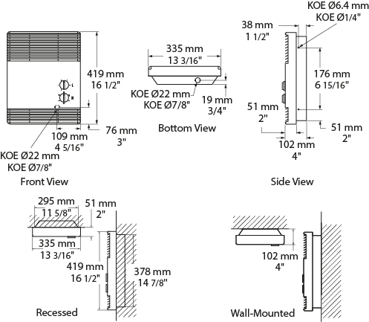

Architect’s and Engineer’s Specifications

Heating Elements – Stitched ribbon-type element.
Outlet Grille – The 20-gauge steel grille has a polyester powder paint finish available in white, almond, or optional stainless steel front cover.
Built-in Controls – Automatic reset thermal cutout prevents overheating.
Fan Motor – Whisper-quiet squirrel-cage fan operates at 33 dBA with 35 CFM and 42.5 dBA with 70 CFM.
Installation Requirements – The air outlet should be installed a minimum of 12-inches above vinyl floors.
Rough In Dimensions – All heaters: 11-5/8” wide x 15-1/2” high x 2” deep.

