Built-in thermostat is not included.

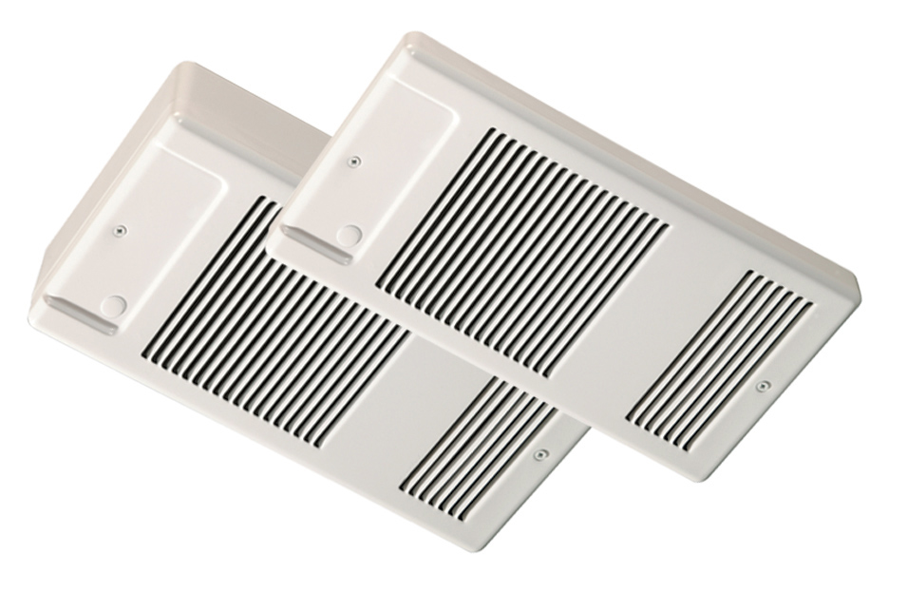

|  |  |  |  |  |  |  |  |
| --- | --- | --- | --- | --- | --- | --- | --- |
| Watts | Volts | Total  Amps (1) | CFM | Approximate Air  Temperature  Rise oF (oC) | Weight  lbs (kg) | Catalog  Number |  |
| 500 | 120 | 4.6 | 40 | 40 (22) | 9 (4) | 941U00500B¶ |  |
| 500/375 | 240/208 | 2.3/2.0 | 40 | 40/30 (22/17) | 9 (4) | 941U00500V¶ |  |
| 750 | 120 | 6.7 | 40 | 60 (33) | 9 (4) | 941U00750B¶ |  |
| 750/563 | 240/208 | 3.3/2.9 | 40 | 60/45 (33/25) | 9 (4) | 941U00750V¶ |  |
| 1000 | 120 | 8.7 | 40 | 80 (44) | 9 (4) | 941U01000B¶ |  |
| 1000/750 | 240/208 | 4.5/3.8 | 40 | 80/60 (44/33) | 9 (4) | 941U01000V¶ |  |
| 1250 | 120 | 10.8 | 80 | 50 (28) | 9 (4) | 941U01250B¶ |  |
| 1250/938 | 240/208 | 5.4/4.7 | 80 | 50/37 (28/21) | 9 (4) | 941U01250V¶ |  |
| 1500 | 120 | 12.9 | 80 | 60 (33) | 9 (4) | 941U01500B¶ |  |
| 1500/1125 | 240/208 | 6.5/5.6 | 80 | 60/45 (33/25) | 9 (4) | 941U01500V¶ |  |

(1) Total Amps = Heating element amps and motor amps.

All models listed are single-phase.

**¶ Standard colors - Add W to end of catalog number for white finish, A for almond finish to the end of catalog number.**

**Factory Built-in Options**

|  |  |  |
| --- | --- | --- |
| Code | Description |  |
| D3 | Disconnect Switch, 277V,  Double-pole, 16 Amp |  |
| C | Factory sealed elements for high humidity applications |  |

**Field-Installed Options**

**(shipped loose for field Installation into heater)**

|  |  |  |
| --- | --- | --- |
| Catalog  Number | Description |  |
| 941-227578¶ | Surface Mounting Box |  |

¶ Standard colors - Add W to end of catalog number for white finish, A for almond finish to the end of catalog number.

**Architect’s and Engineer’s Specifications**

The specified heating equipment shall include an electric, fan-forced air ceiling heater suitable for space heating as manufactured by INDEECO. The ceiling heater shall be designed for wall recess or surface mounting. Heaters shall be third party approved to UL standard 2021. CSA-US or equivalent is acceptable.

**Heater Housing** – The cabinet is 20-gauge steel with a V-shaped recessed box.

**Outlet Grille** – The louvered front grille is made from 22-gauge steel with rounded corners. The grille is finished with an epoxy/polyester powder paint in white or almond. Optional colors: metallic silver, bronze, metallic charcoal, aluminum , and semi-gloss black.

**Built-in Controls** – Automatic reset thermal cutout.

**Fan and Motor** – Quiet, permanently lubricated axial fan operates at 38 dBA at 40 CFM for models up to 1,000 W and 41.3 dBA at 80 CFM for all models rated above 1,000W.

**Installation Requirements** – The air outlet should be installed a minimum of ten inches from the wall and should be oriented towards the center of the room.

**Control** – Room temperature is controlled by a remote wall mounted thermostat which is sold separately.

**Rough In Dimensions** – All heaters: 7-3/16” wide x 14-1/8” high x 3” deep.

