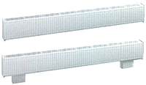



BMI Model: 914U
How to order: Model + Heater Code with color code + Options (example 914U00400NW-1200-T5)
Length  In.  (mm) | Density |  | Watts | Heater Code |  |  |  |  |  |  |  |  | Watts | Heater Code
Length  In.  (mm) | W/Ft | W/m | Watts |  | 208V | Amps |  | 277V | Amps |  | 480V | Amps | 240/208V |  | 240/208V | Amps
27.6  (700) | 150 | 490 | 300 |  | 00300C‡-700 | 1.4 |  | 00300N‡-700 | 1.1 |  | — | — | 300/225 |  | 00300V‡-700 | 1.3/1.1
27.6  (700) | 175 | 574 | 350 |  | 00350C‡ | 1.7 |  | 00350N‡ | 1.3 |  | — | — | 350/263 |  | 00350V‡ | 1.5/1.3
35.4  (900) | 100 | 330 | 300 |  | 00300C‡-900 | 1.4 |  | 00300N‡-900 | 1.1 |  | 00300T‡-900 | 0.6 | 300/225 |  | 00300V‡-900 | 1.3/1.1
35.4  (900) | 150 | 490 | 450 |  | 00450C‡-900 | 2.2 |  | 00450N‡-900 | 1.6 |  | 00450T‡-900 | 0.9 | 450/338 |  | 00450V‡-900 | 1.9/1.6
35.4  (900) | 175 | 574 | 525 |  | 00525C‡ | 2.5 |  | 00525N‡ | 1.9 |  | 00525T‡ | 1.1 | 525/394 |  | 00525V‡ | 2.2/1.9
47.3  (1200) | 100 | 330 | 400 |  | 00400C‡-1200 | 1.9 |  | 00400N‡-1200 | 1.4 |  | 00400T‡-1200 | 0.8 | 400/300 |  | 00400V‡-1200 | 1.7/1.4
47.3  (1200) | 150 | 490 | 600 |  | 00600C‡-1200 | 2.9 |  | 00600N‡-1200 | 2.2 |  | 00600T‡-1200 | 1.3 | 600/450 |  | 00600V‡-1200 | 2.5/2.2
47.3  (1200) | 175 | 574 | 700 |  | 00700C‡ | 3.4 |  | 00700N‡ | 2.5 |  | 00700T‡ | 1.5 | 700/526 |  | 00700V‡ | 2.9/2.5
59.1  (1500) | 100 | 330 | 500 |  | 00500C‡-1500 | 2.4 |  | 00500N‡-1500 | 1.8 |  | 00500T‡-1500 | 1 | 500/375 |  | 00500V‡-1500 | 2.1/1.8
59.1  (1500) | 150 | 490 | 750 |  | 00750C‡-1500 | 3.6 |  | 00750N‡-1500 | 2.7 |  | 00750T‡-1500 | 1.6 | 750/563 |  | 00750V‡-1500 | 3.1/2.7
59.1  (1500) | 175 | 574 | 875 |  | 00875C‡ | 4.2 |  | 00875N‡ | 3.2 |  | 00875T‡ | 1.8 | 875/657 |  | 00875V‡ | 3.6/3.2
70.9  (1800) | 100 | 330 | 600 |  | 00600C‡-1800 | 2.9 |  | 00600N‡-1800 | 2.2 |  | 00600T‡-1800 | 1.3 | 600/450 |  | 00600V‡-1800 | 2.5/2.2
70.9  (1800) | 150 | 490 | 900 |  | 00900C‡-1800 | 4.3 |  | 00900N‡-1800 | 3.2 |  | 00900T‡-1800 | 1.9 | 900/675 |  | 00900V‡-1800 | 3.8/3.2
70.9  (1800) | 175 | 574 | 1050 |  | 01050C‡ | 5.0 |  | 01050N‡ | 3.8 |  | 01050T‡ | 2.2 | 1050/789 |  | 01050V‡ | 4.4/3.8
82.7  (2100) | 100 | 330 | 700 |  | 00700C‡-2100 | 3.4 |  | 00700N‡-2100 | 2.5 |  | 00700T‡-2100 | 1.5 | 700/525 |  | 00700V‡-2100 | 2.9/2.5
82.7  (2100) | 150 | 490 | 1050 |  | 01050C‡-2100 | 5.0 |  | 01050N‡-2100 | 3.8 |  | 01050T‡-2100 | 2.2 | 1050/788 |  | 01050V‡-2100 | 4.4/3.8
82.7  (2100) | 175 | 574 | 1225 |  | 01225C‡ | 5.9 |  | 01225N‡ | 4.4 |  | 01225T‡ | 2.6 | 1225/920 |  | 01225V‡ | 5.1/4.4
94.5  (2400) | 100 | 330 | 800 |  | 00800C‡-2400 | 3.8 |  | 00800N‡-2400 | 2.9 |  | 00800T‡-2400 | 1.7 | 800/600 |  | 00800V‡-2400 | 3.3/2.9
94.5  (2400) | 150 | 490 | 1200 |  | 01200C‡-2400 | 5.8 |  | 01200N‡-2400 | 4.3 |  | 01200T‡-2400 | 2.5 | 1200/900 |  | 01200V‡-2400 | 5.0/4.3
94.5  (2400) | 175 | 574 | 1400 |  | 01400C‡ | 6.7 |  | 01400N‡ | 5.1 |  | 01400T‡ | 2.9 | 1400/1052 |  | 01400V‡ | 5.8/5.1
Other single-phase voltages available. Consult factory. All models listed are single-phase.
‡Standard colors - Add W for white finish or A for almond finish to the end of catalog number when ‡ is indicated.

Factory Built-in Options
Code | Description
D3 | Disconnect Switch, Double-pole, 277V, 20 Amp
F1 | 24V Wireway
L | Custom Length
M1 | High Altitude Automatic Cutout
R1 | 24V Relay, 240V, 22 Amp; 277V,  19 Amp; 600V, 10 Amp
R2 | 24V Relay with Transformer, 240V,  22 Amp; 277V, 19 Amp
R6 | Pneumatic Relay, 480V, 25 Amp
R7 | 24V Proportional Relay
S | Smooth Finish on Heater Back
T1 | Tamperproof Thermostat, Single-pole, 277V, 25 Amp; 600V, 10 Amp with off position
T2 | Tamperproof Thermostat, Double-pole, 277V, 25 Amp; 600V, 10 Amp with off position
T5 | Adjustable Thermostat, Single-pole, 277V,  25 Amp; 600V, 10 Amp with off position
T6 | Adjustable Thermostat, Double-pole, 277V, 25 Amp; 600V, 10 Amp with off position

Field-Installed Options
(shipped loose for field installation into heater)
Catalog  Number | Description
914-166740¶ | Inside Corner
914-166741¶ | Outside Corner
914-166742¶ | Round Pedestal Kit, 3-5”, Qty=2
914-166743¶ | Square Pedestal Kit, 2”, Qty=2
914-166744¶ | Splice Plate 2” Long
914-166745¶ | Finish Joint for Heater with Pedestal
914-166746 | 24V Relay Kit,240V, 22 Amp; 277V, 19 Amp
914-166747 | 24V Relay Kit with Transformer, 208V, 22 Amp
914-166748 | 24V Relay Kit with Transformer, 240V, 22 Amp
914-166749 | 24V Relay Kit with Transformer, 277V, 19 Amp
914B-XXX¶ | Blank Section (specify length in inches-XXX)
914-224761 | Tamperproof Single-pole Thermostat Kit 277V, 25 Amp; 600V, 10 Amp with off position
914-224762 | Tamperproof Double-pole Thermostat Kit 277V, 25 Amp; 600V, 10 Amp with off position
914-224763 | Single-pole Thermostat Kit 277V, 25 Amp; 600V, 10 Amp with off position
214-224764 | Double-pole Thermostat Kit 277V, 25 Amp; 600V, 10 Amp with off position
¶ Standard colors - Add W for white finish or A for almond finish to the end of part number.

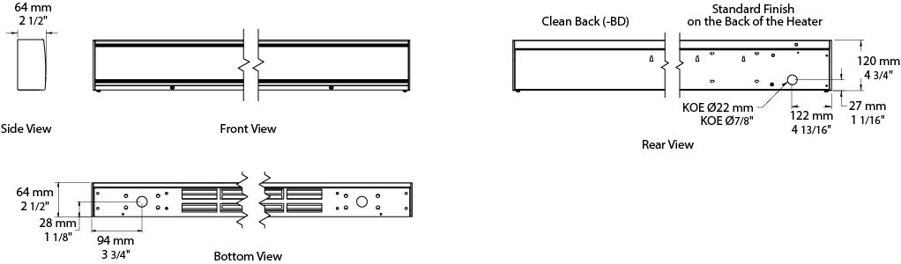

Architect’s and Engineers Specifications

Heating Elements – Stainless steel elements with aluminum fins float on high temperature nylon bushings for quiet operation.
Housing – Cabinet is constructed of 18-gauge steel with a 14-gauge aluminum front and top covers. The unit has a polyester powder paint finish in white or almond. End caps are provided on all units.
Inlet/Outlet Grilles – The fresh air inlet is located on the bottom of the unit. The top outlet grille has openings less than 0.25 inches to discourage tampering with the heating element (pencil-proof).
Built-in Controls – Linear limit, automatic reset thermal cutout.
Electrical Connection – Each heater has a junction box located at the right end and a built-in full length wireway. Separate low voltage wireway is available.
Mounting Requirements – Minimum installation height above the floor is two inches. Field or factory-installed low voltage relay and thermostat kits fit into the right-hand junction box only. These units are not for residential use in the United States.

