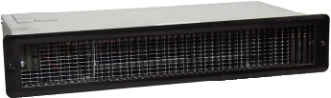

Watts | Volts | Total  Amps (1) | CFM | Approximate Air  Temperature  Rise ºF (ºC) | Weight  lb (kg) | Catalog  Number
1000/500 | 120 | 8.8/4.6 | 80 | 20 (11) | 13 (6) | 938U01000B¶
500/375 | 240/208 | 2.5/2.3 | 80 | 20/15 (11/8) | 13 (6) | 938U01000V¶
1000/750 | 240/208 | 4.6/4.1 | 80 | 40/30 (22/17) | 13 (6) | 938U01000V¶
(1) Total Amps = Heating element amps and motor amps.
¶ Standard colors - Add W white finish, A for almond, or BK for black to the end of the catalog number.

Factory Built-in Options
Code | Description
T5 | Adjustable thermostat, single-pole,  25 Amp with off position
T6 | Adjustable thermostat, double-pole  25 Amp with off position

Field-Installed Options
(shipped loose for field Installation into heater)
Catalog  Number | Description
938-158480¶ | Adjustable thermostat kit, single-pole, 25 Amp with off position
938-218240¶ | Adjustable thermostat kit, double-pole, 25 Amp with off position

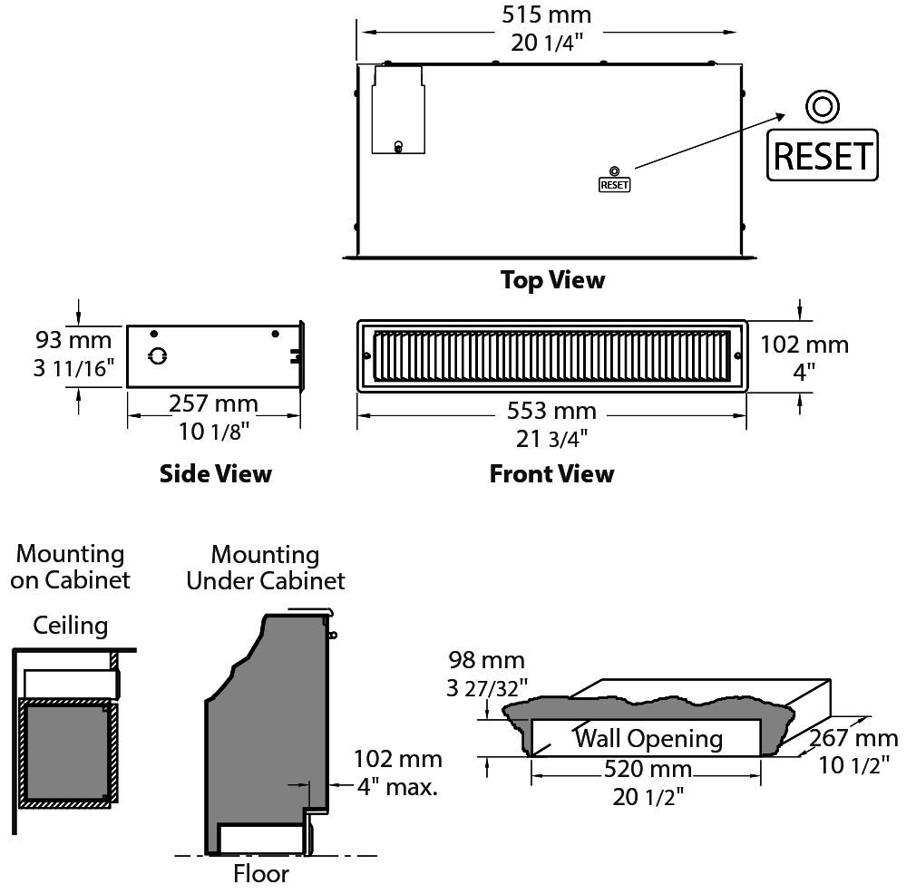
Architect’s and Engineer’s Specifications
The INDEECO TSI series fan-forced toe space heater shall be suitable for installation in toe space areas under cabinets, soffits above cabinets or in stair risers. The heater shall be _{c}CSA_{US} approved to Underwriters Laboratory (UL) standards.
Heater frame shall consist of a commercial grade galvanized steel box with an electrical enclosure and knockouts for field wiring. The heater shall have factory mounted and wired heating elements, fan motor with tangential blower and an automatic and manual reset overtemperature protection. One time heat limiters or other fusible overtemperature devices are not acceptable.
Heating elements shall be of a non-glowing design consisting of 80/20 nickel chromium resistance wire centered in a steel tube filled with magnesium oxide. A steel fin is to be helically wound and brazed onto the tube. The elements shall cover the entire air discharged area to ensure uniform heating of all discharge air. The wattage output of the unit shall be adjustable by removing a jumper wire.
Fan motor shall be permanently lubricated. Optional single-pole adjustable thermostat shall be specified when the unit will not utilize a wall mounted thermostat. The automatic and manual reset overtemperature thermal cutouts shall be bi-metal snap-acting type to de-energize the heater in the event of overheating.
Outlet grille shall be heavy 20-gauge steel finished with an epoxy-polyester powder coating. It will be attached to the heater with two screws.
Rough in Dimensions – All heaters: 20-1/2” wide x 3-27/32” high x 10-1/2” deep.
