
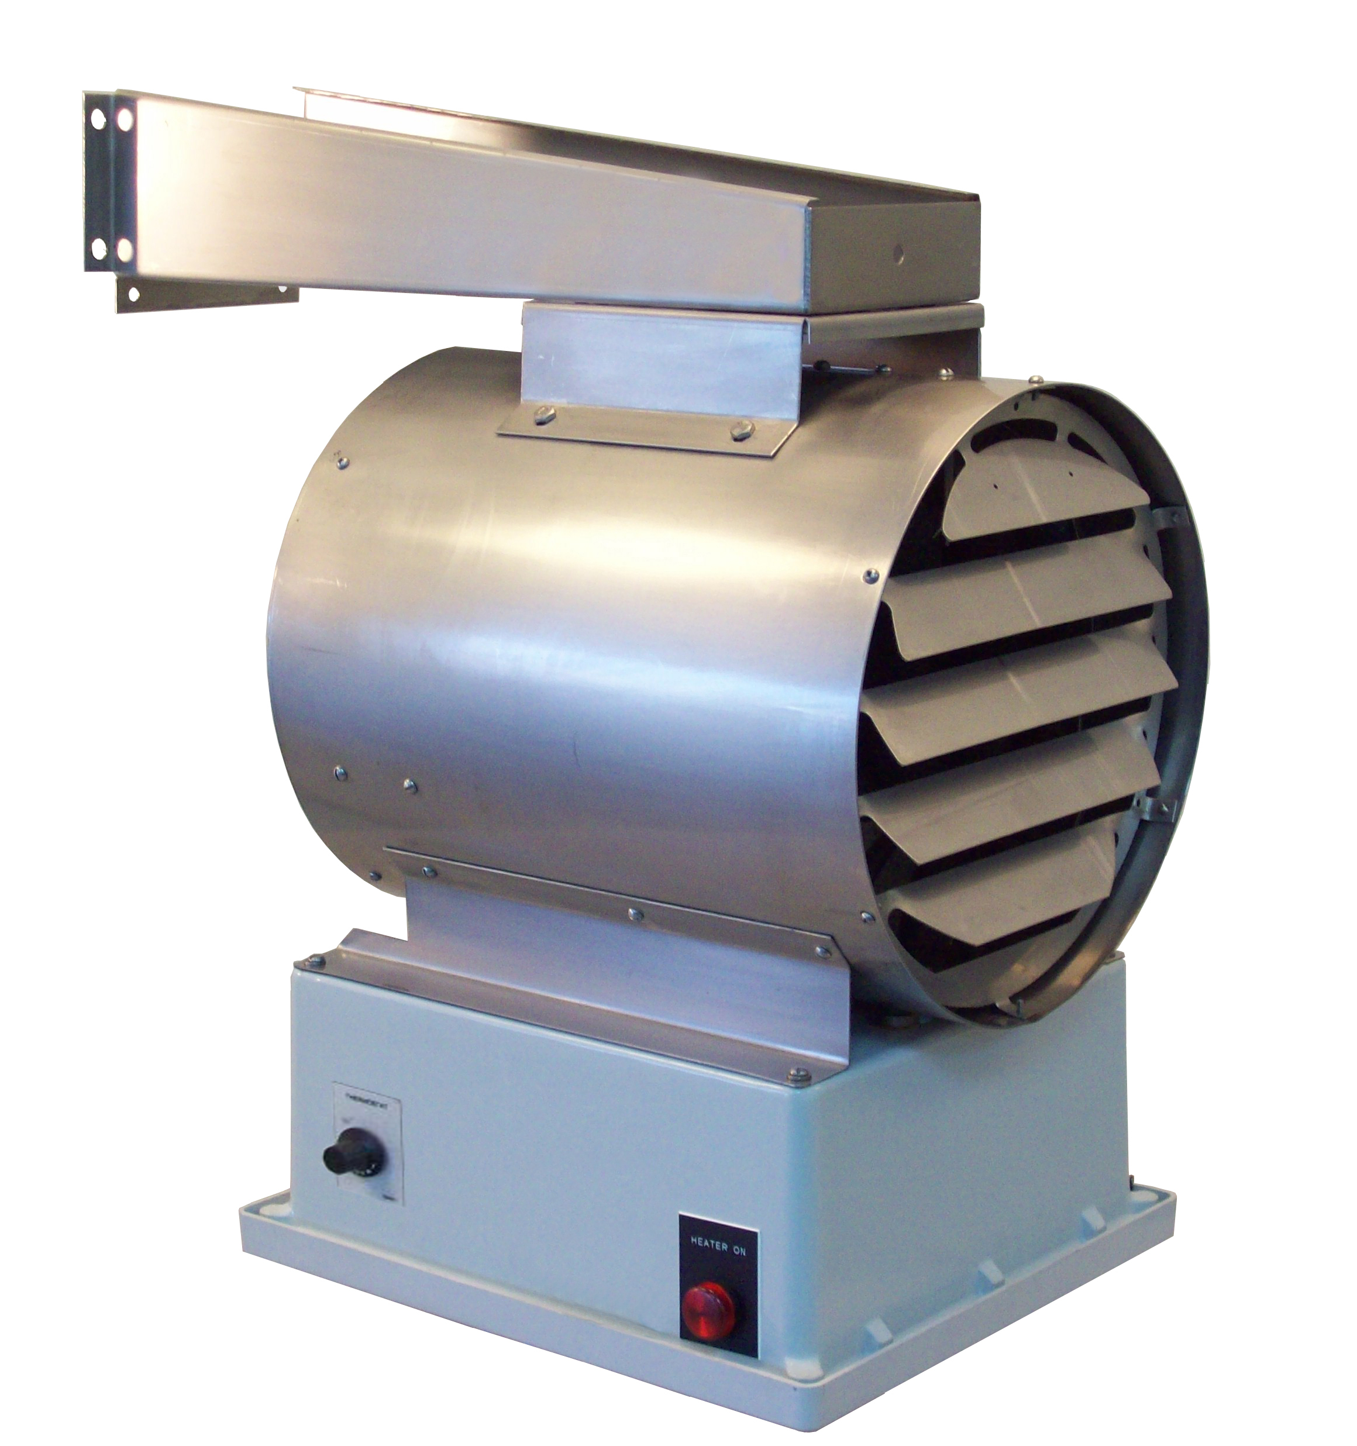
KW | Volts | Ph | Total  Amps  (1) | Approximate Air  Temperature Rise ºF (ºC) | Motor |  |  | Catalog  Number | Availability  Code  (2)(3) | 2-Stage  Control
 |  |  |  |  | HP | Volts | Ph
2 | 120 | 1 | 21 | 9 (5) | 1/4 | 120 | 1 | 234-U11R-0020B | AS | 1B
2 | 208 | 1 | 12 | 9 (5) | 1/4 | 208 | 1 | 234-U11R-0020C | AS | 1B
2 | 240 | 1 | 11 | 9 (5) | 1/4 | 240 | 1 | 234-U11R-0020J | AS | 1B
2 | 277 | 1 | 10 | 9 (5) | 1/4 | 277 | 1 | 234-U11R-0020N | AS | 1B
2 | 347 | 1 | 7 | 9 (5) | 1/4 | 347 | 1 | 234-U11R-0020I | AS | 1B
3 | 120 | 1 | 29 | 14 (8) | 1/4 | 120 | 1 | 234-U11N-0030B | AS | 1A
3 | 208 | 1 | 17 | 14 (8) | 1/4 | 208 | 1 | 234-U11N-0030C | AS | 1A
3 | 240 | 1 | 15 | 14 (8) | 1/4 | 240 | 1 | 234-U11N-0030J | AS | 1A
3 | 277 | 1 | 13 | 14 (8) | 1/4 | 277 | 1 | 234-U11R-0030N | AS | 1A
3 | 347 | 1 | 11 | 14 (8) | 1/4 | 347 | 1 | 234-U11N-0030I | AS | 1A
3 | 480 | 1 | 8 | 14 (8) | 1/4 | 480 | 1 | 234-U11N-0030T | AS | 1A
3 | 208 | 3 | 11 | 14 (8) | 1/4 | 208 | 1 | 234-U11N-0030D | AS | 1A
3 | 240 | 3 | 10 | 14 (8) | 1/4 | 240 | 1 | 234-U11N-0030K | AS | 1A
3 | 480 | 3 | 5 | 14 (8) | 1/4 | 480 | 1 | 234-U11N-0030U | AS | 1A
3 | 600 | 3 | 4 | 14 (8) | 1/4 | 600 | 1 | 234-U11N-0030Z | AS | 1A
5 | 208 | 1 | 27 | 24 (13) | 1/4 | 208 | 1 | 234-U11R-0050C | AS | 1B
5 | 240 | 1 | 23 | 24 (13) | 1/4 | 240 | 1 | 234-U11R-0050J | AS | 1B
5 | 277 | 1 | 20 | 24 (13) | 1/4 | 277 | 1 | 234-U11R-0050N | AS | 1B
5 | 347 | 1 | 17 | 24 (13) | 1/4 | 347 | 1 | 234-U11R-0050I | AS | 1B
5 | 480 | 1 | 12 | 24 (13) | 1/4 | 480 | 1 | 234-U11R-0050T | AS | 1B
5 | 208 | 3 | 16 | 24 (13) | 1/4 | 208 | 1 | 234-U11N-0050D | AS | 1A
5 | 240 | 3 | 15 | 24 (13) | 1/4 | 240 | 1 | 234-U11N-0050K | AS | 1A
5 | 480 | 3 | 8 | 24 (13) | 1/4 | 480 | 1 | 234-U11N-0050U | AS | 1A
5 | 600 | 3 | 6 | 24 (13) | 1/4 | 600 | 1 | 234-U11N-0050Z | AS | 1A
7.5 | 208 | 1 | 39 | 35 (19) | 1/4 | 208 | 1 | 234-U11N-0080C | AS | 1A
7.5 | 240 | 1 | 34 | 35 (19) | 1/4 | 240 | 1 | 234-U11N-0080J | AS | 1A
7.5 | 277 | 1 | 29 | 35 (19) | 1/4 | 277 | 1 | 234-U11N-0080N | AS | 1A
7.5 | 347 | 1 | 24 | 35 (19) | 1/4 | 347 | 1 | 234-U11N-0080I | AS | 1A
7.5 | 480 | 1 | 17 | 35 (19) | 1/4 | 480 | 1 | 234-U11N-0080T | AS | 1A
7.5 | 208 | 3 | 23 | 35 (19) | 1/4 | 208 | 1 | 234-U11N-0080D | AS | 1A
7.5 | 240 | 3 | 21 | 35 (19) | 1/4 | 240 | 1 | 234-U11N-0080K | AS | 1A
7.5 | 480 | 3 | 11 | 35 (19) | 1/4 | 480 | 1 | 234-U11N-0080U | AS | 1A
7.5 | 600 | 3 | 9 | 35 (19) | 1/4 | 600 | 1 | 234-U11N-0080Z | AS | 1A
9 | 208 | 1 | 46 | 20 (11) | 1/4 | 208 | 1 | 234-U11N-0090C | AS | 1A
9 | 240 | 1 | 40 | 20 (11) | 1/4 | 240 | 1 | 234-U11N-0090J | AS | 1A
9 | 277 | 1 | 35 | 20 (11) | 1/4 | 277 | 1 | 234-U11N-0090N | AS | 1A
9 | 347 | 1 | 29 | 20 (11) | 1/4 | 347 | 1 | 234-U11N-0090I | AS | 1A
9 | 480 | 1 | 20 | 20 (11) | 1/4 | 480 | 1 | 234-U11N-0090T | AS | 1A
9 | 208 | 3 | 28 | 20 (11) | 1/4 | 208 | 1 | 234-U11N-0090D | AS | 1A
9 | 240 | 3 | 24 | 20 (11) | 1/4 | 240 | 1 | 234-U11N-0090K | AS | 1A
9 | 480 | 3 | 12 | 20 (11) | 1/4 | 480 | 1 | 234-U11N-0090U | AS | 1A
9 | 600 | 3 | 10 | 20 (11) | 1/4 | 600 | 1 | 234-U11N-0090Z | AS | 1A

(1) Total Amps = Heating element amps and motor amps.
(2) Availability Code: AS=Assembly stock
(3) Stock heaters ordered with custom options subject to longer delivery.
NOTE: 2-stage heaters can be field wired as single stage.
1A=Optional 2-stage control, unbalanced (option ‘X’).
1B=Optional 2-stage control, balanced (option ‘X’).

KW | Volts | Ph | Total  Amps  (1) | Approximate Air  Temperature Rise ºF (ºC) | Motor |  |  | Catalog  Number | Availability  Code  (2)(3) | 2-Stage  Control
 |  |  |  |  | HP | Volts | Ph
10 | 240 | 1 | 44 | 22 (12) | 1/4 | 240 | 1 | 234-U11N-0100J | AS | 1A
10 | 277 | 1 | 39 | 22 (12) | 1/4 | 277 | 1 | 234-U11N-0100N | AS | 1A
10 | 347 | 1 | 32 | 22 (12) | 1/4 | 347 | 1 | 234-U11N-0100I | AS | 1A
10 | 480 | 1 | 22 | 22 (12) | 1/4 | 480 | 1 | 234-U11N-0100T | AS | 1B
10 | 208 | 3 | 30 | 22 (12) | 1/4 | 208 | 1 | 234-U11N-0100D | AS | 1A
10 | 240 | 3 | 27 | 22 (12) | 1/4 | 240 | 1 | 234-U11N-0100K | AS | 1A
10 | 480 | 3 | 14 | 22 (12) | 1/4 | 480 | 1 | 234-U11N-0100U | AS | 1A
10 | 600 | 3 | 11 | 22 (12) | 1/4 | 600 | 1 | 234-U11N-0100Z | AS | 1A
12 | 277 | 1 | 46 | 26 (14) | 1/4 | 277 | 1 | 234U11N-0120N | AS | 1A
12 | 347 | 1 | 38 | 26 (14) | 1/4 | 347 | 1 | 234-U11N-0120I | AS | 1A
12 | 480 | 1 | 27 | 26 (14) | 1/4 | 480 | 1 | 234-U11N-0120T | AS | 1A
12 | 208 | 3 | 36 | 26 (14) | 1/4 | 208 | 1 | 234-U11N-0120D | AS | 1A
12 | 240 | 3 | 32 | 26 (14) | 1/4 | 240 | 1 | 234-U11N-0120K | AS | 1A
12 | 480 | 3 | 16 | 26 (14) | 1/4 | 480 | 1 | 234-U11N-0120U | AS | 1A
12 | 600 | 3 | 13 | 26 (14) | 1/4 | 600 | 1 | 234-U11N-0120Z | AS | 1A
12.5 | 347 | 1 | 39 | 17 (9) | 1/4 | 347 | 1 | 234-U11L-0130I | AS | 1A
12.5 | 208 | 3 | 37 | 17 (9) | 1/4 | 208 | 1 | 234-U11L-0130D | AS | 1A
12.5 | 240 | 3 | 33 | 17 (9) | 1/4 | 240 | 1 | 234-U11L-0130K | AS | 1A
12.5 | 480 | 3 | 17 | 17 (9) | 1/4 | 480 | 1 | 234-U11L-0130U | AS | 1A
12.5 | 600 | 3 | 14 | 17 (9) | 1/4 | 600 | 1 | 234-U11L-0130Z | AS | 1A
15 | 347 | 1 | 47 | 21 (12) | 1/4 | 347 | 1 | 234-U11L-0150I | AS | 1A
15 | 208 | 3 | 44 | 21 (12) | 1/4 | 208 | 1 | 234-U11L-0150D | AS | 1A
15 | 240 | 3 | 39 | 21 (12) | 1/4 | 240 | 1 | 234-U11L-0150K | AS | 1A
15 | 480 | 3 | 20 | 21 (12) | 1/4 | 480 | 1 | 234-U11L-0150U | AS | 1A
15 | 600 | 3 | 16 | 21 (12) | 1/4 | 600 | 1 | 234-U11L-0150Z | AS | 1A
20 | 480 | 3 | 26 | 28 (16) | 1/4 | 480 | 1 | 234-U11L-0200U | AS | 1A
20 | 600 | 3 | 21 | 28 (16) | 1/4 | 600 | 1 | 234-U11L-0200Z | AS | 1A
25 | 480 | 3 | 32 | 35 (19) | 1/4 | 480 | 1 | 234-U11A-0250U | AS | 1B
25 | 600 | 3 | 26 | 35 (19) | 1/4 | 600 | 1 | 234-U11A-0250Z | AS | 1B
30 | 480 | 3 | 38 | 42 (23) | 1/4 | 480 | 1 | 234-U11A-0300U | AS | 1B
30 | 600 | 3 | 31 | 42 (23) | 1/4 | 600 | 1 | 234-U11A-0300Z | AS | 1B
35 | 480 | 3 | 44 | 48 (27) | 1/4 | 480 | 1 | 234-U11A-0350U | AS | 1B
35 | 600 | 3 | 35 | 48 (27) | 1/4 | 600 | 1 | 234-U11A-0350Z | AS | 1B
38.4 | 480 | 3 | 48 | 54 (30) | 1/4 | 480 | 1 | 234-U11A-0390U | AS | 1B
38.4 | 600 | 3 | 38 | 54 (30) | 1/4 | 600 | 1 | 234-U11A-0390Z | AS | 1B
47 | 600 | 3 | 47 | 64 (36) | 1/4 | 600 | 1 | 234-U11A-0470Z | AS | 1B
(1) Total Amps = Heating element amps and motor amps.
(2) Availability Code: AS=Assembly stock
(3) Stock heaters ordered with custom options subject to longer delivery.
NOTE: 2-stage heaters can be field wired as single stage.
1A=Optional 2-stage control, unbalanced (option ‘X’).
1B=Optional 2-stage control, balanced (option ‘X’).
Factory Built-in Options
Code | Description |  | Availability  Code  (1)(2)
B | Delete swivel mounting bracket. Heater installs from the ceiling with field-furnished threaded rods | Up to 12 KW  Over 12 KW | AS
C | Epoxy painted stainless steel parts housing and grilles |  | C
D | Power disconnect switch |  | AS
E | Monel finned tubular elements |  | C
F8 | Fan motor fusing with disconnecting contactor |  | C
L | “Heater On” pilot light |  | AS
M | Secondary manual reset overtemperature cutout. Required for U.S. Coast Guard and ABS Approved designs. |  | AS
S | Three-position selector switch (heater-standby-fan) |  | AS
T | 1-stage built-in thermostat 40 to 100°F (5 to 38°C) range |  | AS
T | 2-stage built-in thermostat 40 to 120°F (5 to 49°C) range (Option X required) |  | C
V | 120 volt control circuit, fused secondary and grounded |  | AS
X | 2-Stage control |  | C
(1) Availability Code: AS = Assembly Stock, C = Custom.
(2) Assembly stock Heaters ordered with custom options are subject to longer delivery.

Accessory Remote Room Thermostat
Catalog  Number | Description | Availability  Code
1004328 | Washdown/Corrosion-Resistant wall-mounted thermostat for non-hazardous locations 40º - 110ºF (4º - 43ºC) range. | AS
1026347 | Washdown/Corrosion-Resistant wall-mounted thermostat for non-hazardous locations 40º - 100ºF (4º - 38ºC) range. | AS

Dimensions, Airflows and Weights |  | KW
 |  | 2-7.5 | 9-12 | 12.5-47
Overall  Heater  Dimensions | “X” Inch (cm) | 15 ½ (39) | 15 ½ (39) | 26 (66)
Overall  Heater  Dimensions | “Y” Inch (cm) | 21 ½ (55) | 21 ½ (55) | 28 (71)
Overall  Heater  Dimensions | “Z” Inch (cm) | 13 (33) | 13 (33) | 20 (51)
Mounting  Hole  Dimensions | “BH” Inch (cm) | 4 ¼ (11) | 4 ¼ (11) | 7 1/8 (18)
Mounting  Hole  Dimensions | “BL” Inch (cm) | 19 ½ (50) | 19 ½ (50) | 22 ¼ (57)
Mounting  Hole  Dimensions | “M” Inch (cm) | 8 ½ (22) | 8 ½ (22) | 3 ¼ (8)
Airflow  Characteristics | Air Volume CFM (cubic meters/hr) | 700 (1189) | 1450 (2463) | 2400 (4077)
Airflow  Characteristics | Air Throw Feet (m) | 26 (8) | 43 (13) | 50 (15)
Airflow  Characteristics | Outlet Velocity FPM (meters/min) | 760 (232) | 1575 (481) | 1200 (366)
Weight | Net Lbs (kgs) | 56 (25) | 56 (25) | 115 (32)
Weight | Shipping Lbs | 70 (32) | 70 (32) | 130 (60)

Architect’s and Engineer’s Specifications

A sample specification can be prepared by using the following information. A check box has been supplied so that you may mark those sections which you require. Material which is part of the standard TRIAD® specification has already been checked.

- 1. Electric unit heaters shall be INDEECO TRIAD®, with built-in controls, UL and cUL Listed for corrosive areas and NEMA 4X hose down requirements. Heater to be forced fan type of the kW rating, voltage and phase specified in the schedule.
- 2. Finned tubular heating elements shall be of type:
Monel sheath with mechanically wound monel fins and stainless steel mounting fittings (standard).
316 stainless steel sheath with mechanically wound stainless steel fins and mounting fittings.
- 3. The motor shall be UL Recognized, totally enclosed with permanently lubricated ball bearings, designed to resist moisture and corrosion, fitted with an epoxy-coated aluminum fan blade and factory wired to NEMA 4X enclosure.
- 4. Heating elements and motor to be enclosed in round, heavy 16 gauge stainless steel shroud, with stainless steel louvered outlet grille and plated rear grille.
- 5. Single point, line voltage connection for incoming power for 120, 208, 240, 277,347, 480 and 600V heaters.
- 6. NEMA 4X enclosure to house element terminals and the following standard built-in controls: automatic reset overtemperature cutout, 24V control transformer, fan delay relay, required contactors, and terminal block for field wiring. For heaters above 12 kW, a separate motor contactor will be supplied.
7. The following optional controls are to be built-in and factory-prewired in the NEMA 4X enclosure:
Thermostat with external adjustable knob
Three position selector switch
“Heater On” pilot light to indicate when heating elements are energized
Secondary manual reset thermal cutout (required for U.S. Coast Guard and ABS Approved designs)
Disconnect switch
Fan motor fusing with disconnecting contactor
120V control circuit
8. Accessory thermostat shall be furnished with each heater for remote wall mounting. Thermostat shall be UL Listed with NEMA 4X enclosure suitable for wet and corrosive areas.

23-5100-80-6

