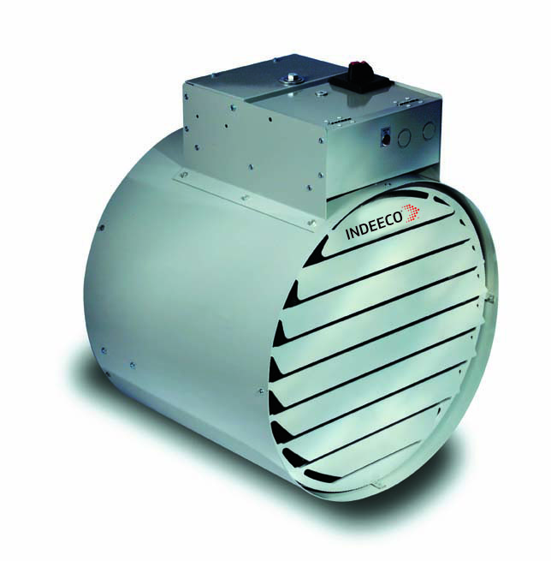

KW | Volts | Ph | Total Amps (1) | Approximate Air Temperature Rise°F (°C) | Motor |  |  | Catalog  Number | 2-Stage  Control
 |  |  |  |  | HP | Volts | Ph
5 | 208 | 1 | 27 | 35 (19) | 1/4 | 208 | 1 | 238-UT05C | 1A
 | 240 | 1 | 23 | 35 (19) | 1/4 | 240 | 1 | 238-UT05J | 1A
 | 277 | 1 | 20 | 26 (14) | 1/4 | 277 | 1 | * 238-UT05N | 1A
 | 347 | 1 | 17 | 26 (14) | 1/4 | 347 | 1 | * 238-UT05I | N/A
 | 480 | 1 | 12 | 35 (19) | 1/4 | 480 | 1 | 238-UT05T | N/A
 | 600 | 1 | 10 | 26 (14) | 1/4 | 600 | 1 | * 238-UT05Y | N/A
 | 208 | 3 | 16 | 35 (19) | 1/4 | 208 | 1 | 238-UT05D | 1A
 | 240 | 3 | 15 | 35 (19) | 1/4 | 240 | 1 | 238-UT05K | 1A
 | 480 | 3 | 8 | 35 (19) | 1/4 | 480 | 1 | 238-UT05U | N/A
 | 600 | 3 | 6 | 26 (14) | 1/4 | 600 | 1 | * 238-UT05Z | N/A
7.5 | 208 | 1 | 39 | 53 (29) | 1/4 | 208 | 1 | 238-UT08C | N/A
 | 240 | 1 | 34 | 53 (29) | 1/4 | 240 | 1 | 238-UT08J | N/A
 | 277 | 1 | 29 | 39 (22) | 1/4 | 277 | 1 | * 238-UT08N | N/A
 | 347 | 1 | 24 | 39 (22) | 1/4 | 347 | 1 | * 238-UT08I | N/A
 | 480 | 1 | 17 | 53 (29) | 1/4 | 480 | 1 | 238-UT08T | N/A
 | 600 | 1 | 14 | 39 (22) | 1/4 | 600 | 1 | * 238-UT08Y | N/A
 | 208 | 3 | 23 | 53 (29) | 1/4 | 208 | 1 | 238-UT08D | 1A
 | 240 | 3 | 21 | 53 (29) | 1/4 | 240 | 1 | 238-UT08K | 1A
 | 480 | 3 | 11 | 53 (29) | 1/4 | 480 | 1 | 238-UT08U | N/A
 | 600 | 3 | 9 | 39 (22) | 1/4 | 600 | 1 | * 238-UT08Z | N/A
9 | 208 | 1 | 46 | 64 (36) | 1/4 | 208 | 1 | 238-UT09C | N/A
 | 240 | 1 | 40 | 64 (36) | 1/4 | 240 | 1 | 238-UT09J | N/A
 | 277 | 1 | 35 | 47 (26) | 1/4 | 277 | 1 | * 238-UT09N | N/A
 | 347 | 1 | 29 | 47 (26) | 1/4 | 347 | 1 | * 238-UT09I | N/A
 | 480 | 1 | 20 | 64 (36) | 1/4 | 480 | 1 | 238-UT09T | N/A
 | 600 | 1 | 17 | 47 (26) | 1/4 | 600 | 1 | * 238-UT09Y | N/A
 | 208 | 3 | 28 | 64 (36) | 1/4 | 208 | 1 | 238-UT09D | 1A
 | 240 | 3 | 24 | 64 (36) | 1/4 | 240 | 1 | 238-UT09K | 1A
 | 480 | 3 | 12 | 64 (36) | 1/4 | 480 | 1 | 238-UT09U | N/A
 | 600 | 3 | 10 | 47 (26) | 1/4 | 600 | 1 | * 238-UT09Z | N/A
10 | 240 | 1 | 44 | 52 (29) | 1/4 | 240 | 1 | * 238-UT10J | N/A
 | 277 | 1 | 39 | 52 (29) | 1/4 | 277 | 1 | * 238-UT10N | N/A
 | 347 | 1 | 32 | 52 (29) | 1/4 | 347 | 1 | * 238-UT10I | N/A
 | 480 | 1 | 22 | 52 (29) | 1/4 | 480 | 1 | * 238-UT10T | N/A
 | 600 | 1 | 19 | 52 (29) | 1/4 | 600 | 1 | * 238-UT10Y | N/A
 | 208 | 3 | 30 | 52 (29) | 1/4 | 208 | 1 | * 238-UT10D | N/A
 | 240 | 3 | 27 | 52 (29) | 1/4 | 240 | 1 | * 238-UT10K | 1A
 | 480 | 3 | 14 | 52 (29) | 1/4 | 480 | 1 | * 238-UT10U | N/A
 | 600 | 3 | 11 | 52 (29) | 1/4 | 600 | 1 | * 238-UT10Z | N/A
12 | 277 | 1 | 46 | 62 (34) | 1/4 | 277 | 1 | * 238-UT12N | N/A
 | 347 | 1 | 38 | 62 (34) | 1/4 | 347 | 1 | * 238-UT12I | N/A
 | 480 | 1 | 27 | 62 (34) | 1/4 | 480 | 1 | * 238-UT12T | N/A
 | 208 | 3 | 36 | 62 (34) | 1/4 | 208 | 1 | * 238-UT12D | N/A
 | 240 | 3 | 32 | 62 (34) | 1/4 | 240 | 1 | * 238-UT12K | N/A
 | 480 | 3 | 16 | 62 (34) | 1/4 | 480 | 1 | * 238-UT12U | N/A
 | 600 | 3 | 13 | 62 (34) | 1/4 | 600 | 1 | * 238-UT12Z | N/A
12.5 | 347 | 1 | 39 | 22 (12) | 1/4 | 347 | 1 | * 238-UL13I | N/A
 | 208 | 3 | 37 | 31 (17) | 1/4 | 208 | 1 | 238-UL13D | N/A
 | 240 | 3 | 33 | 31 (17) | 1/4 | 240 | 1 | 238-UL13K | N/A
 | 480 | 3 | 17 | 31 (17) | 1/4 | 480 | 1 | 238-UL13U | N/A
 | 600 | 3 | 14 | 22 (12) | 1/4 | 600 | 1 | * 238-UL13Z | N/A
15 | 347 | 1 | 47 | 27 (15) | 1/4 | 347 | 1 | * 238-UL15I | N/A
 | 208 | 3 | 44 | 38 (21) | 1/4 | 208 | 1 | 238-UL15D | N/A
 | 240 | 3 | 39 | 38 (21) | 1/4 | 240 | 1 | 238-UL15K | N/A
 | 480 | 3 | 20 | 38 (21) | 1/4 | 480 | 1 | 238-UL15U | N/A
 | 600 | 3 | 16 | 27 (15) | 1/4 | 600 | 1 | * 238-UL15Z | N/A
20 | 480 | 3 | 26 | 35 (19) | 1/4 | 480 | 1 | * 238-UL20U | N/A
 | 600 | 3 | 21 | 35 (19) | 1/4 | 600 | 1 | * 238-UL20Z | N/A
25 | 480 | 3 | 32 | 66 (37) | 1/4 | 480 | 1 | 238-UA25U | 1B
 | 600 | 3 | 26 | 44 (24) | 1/4 | 600 | 1 | * 238-UA25Z | 1B
30 | 480 | 3 | 38 | 79 (44) | 1/4 | 480 | 1 | 238-UA30U | 1B
 | 600 | 3 | 31 | 53 (29) | 1/4 | 600 | 1 | * 238-UA30Z | 1B
35 | 480 | 3 | 44 | 61 (34) | 1/4 | 480 | 1 | *238-UA35U | 1B
 | 600 | 3 | 35 | 61 (34) | 1/4 | 600 | 1 | * 238-UA35Z | 1B
38.4 | 480 | 3 | 48 | 70 (39) | 1/4 | 480 | 1 | * 238-UA39U | 1B
 | 600 | 3 | 38 | 70 (39) | 1/4 | 600 | 1 | * 238-UA39Z | 1B

* Premium motor comes standard with heater.
(1) Total Amps = Heating element amps and motor amps.
Consult factor for other KW or optional 2 stage operation.

Note: 2-stage heaters can be field wired as single stage.
1A = Optional 2-stage control, unbalanced (option “Z”)
1B = Optional 2-stage control, balanced (option “Z”)
Factory Built-in Options
Code | Description
B | No mounting bracket
C | Substitute wall mounting bracket with ceiling bracket
D | Power Disconnect Switch
G | Adjustable Outlet Louvers | 1-12 KW
 |  | 12.5-38.4 KW
H | Premium Fan Motor
L | “Heater On” Pilot Light
M | Manual Reset Thermal Cutout.
R | Built-in Fan Relay - Required for Remote Fan Switch
S | Three-position Selector Switch (Heater-Standby-Fan)
T | Built-in Thermostat 40° to 120°F (-4° to 49°C) Range
X | No Transformer - Customer supplied control voltage
Dimensions, Weights and Air Throws
KW | Dimensions - In. (cm) |  |  |  |  | Weight  Lb (kgs) | Maximum Air  Throw - Ft. (m)
 | M | W | X | Y | Z
1 - 12 | 8 ¼ (21) | 8 ¾ (22) | 15 (38) | 17 (43) | 13 (41) | 45 (20) | 15 (5)
12.5 - 20 | 7 (18) | 5 ½ (14) | 16 ¼ (41) | 23 ½ (60) | 19 ¼ (49) | 60 (27) | 50 (15)
25 - 38.4 | 4 (10) | 5 ½ (14) | 20 ¾ (53) | 23 ½ (60) | 19 ¼ (49) | 80 (36) | 50 (15)

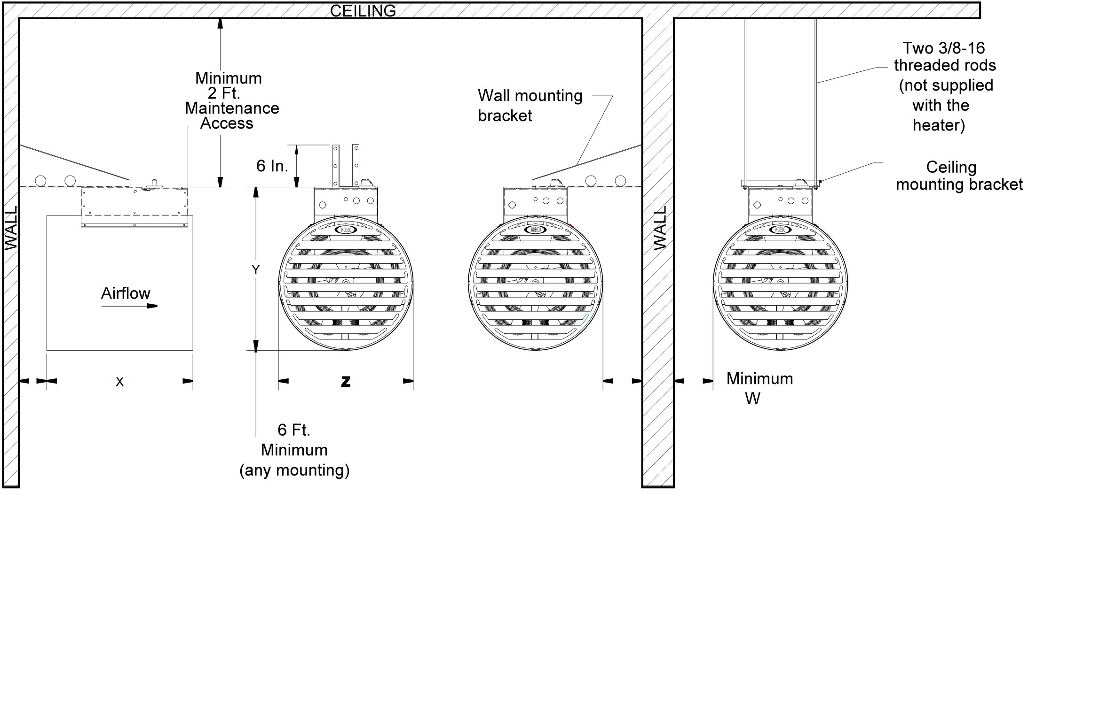
M

Motor Data
Description | RPM | Airflow - CFM (cubic meters/hr) |  |  | Noise Level (dB)
 |  | 1-12 kW | 12.5-20 kW | 25-38.4 kW | 1-12 kW | 12.5-20 kW | 25-38.4 kW
Standard | 1200 | 362 (615) | 1342 (2280) | 1237 (2102) | 64 | 68 | 68
Premium | 1800 | 618 (1050) | 1774 (3014) | 1635 (2778) | 75 | 84 | 84
Architect’s and Engineer’s Specifications

A sample specification can be prepared b using the following information. A check box has been supplied so that you may mark those sections which you require. Material which is part of the standard INDEECO Industrial Unit Heater specification has already been checked.

- 1. Electric Industrial Unit Heaters shall be manufactured by INDEECO, with built-in controls and UL Listed. Heater to be forced fan type of the kW rating, voltage and phase specified in the schedule.
- 2. The heating elements shall be of type 304 stainless steel finned tubular construction.
- 3. The motor shall be UL Recognized with built-in thermal protection.
- 4. Heating elements and motor to be enclosed in a round, heavy gauge galvanized steel shroud with a baked powder coat finish.
- 5. Wall mounted bracket with single point suspension. The heater can be rotated a full 180° arc.
- 6. Outlet grille with 45° angled louvers. Inlet grille that complies with OSHA requirements for fan blade guard.
- 7. Single point, line voltage connection for incoming power. Heater, fan and controls can all be connected to the same branch circuit.
8. The following optional components are to be built-in and factory pre-wired:
Heater Control thermostat - 0° to 120° F (-18° to 49° C) range
Three position selector switch (Heater - Standby - Fan)
“Heater On” pilot light to indicate when hating elements are energized
Manual reset thermal cutout
Power disconnect switch
Fan relay - remote fan switch
9. Substitute high performance fan motor to increase horizontal throw distance (comes standard on some unit sizes).
10. Add adjustable outlet louvers to better direct flow.
11. Delete transformer (customer supplied control voltage required.)
12. Replace wall mounted bracket with mounting bracket for ceiling installations. The heater can be rotated a full 180° arc.
13. Add an accessory wall mounted room thermostat. Adjustable from 50° to 90° F (10° to 32° C).

